**MitchTech Station Logistics**

Automated Specialist Trading for X Rebirth

Author: Wysiwyg

Version 1.00 – 1st February 2015

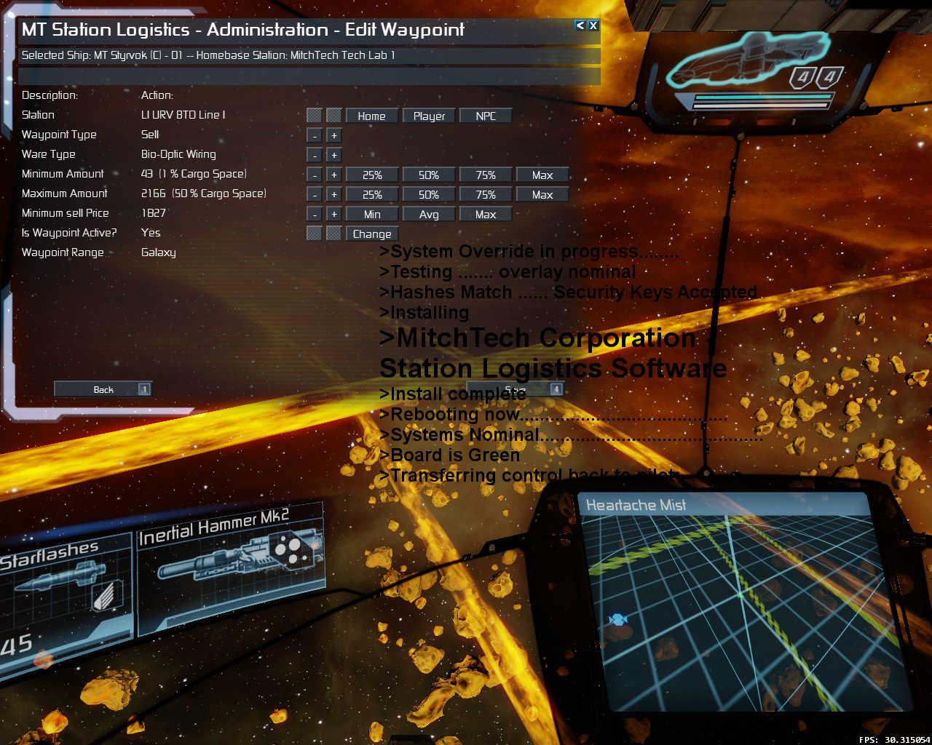

# Contents

Contents 2

Summary 3

Introduction 3

Features 3

Uninstalling the mod 3

Known issues 3

TODO: Suggestions and bug reports are most welcome 3

Technical 4

Credits 4

Quick Start Guide 5

Install the mod 5

Stuff you need to get started 5

Adding the trader 5

Assigning the ship to a station 6

Adding Waypoints 6

Add or Edit a waypoint 7

Reference Section 10

Introduction 10

The Administration Screen 10

i. Administer Trade Ships 10

ii. Reports 10

iii. Configure 10

The Administer trade ships screen 10

i. Buttons 10

The Waypoint List Screen 11

i. Buttons 11

The Waypoint Edit Screen 12

The Reports Screen 13

i. Buttons 13

The crew log screen 14

i. Buttons 14

The Ship Log Screen 14

i. Buttons 14

Technical Information 15

Usage examples 15

1. Simple guaranteed ecell supply to all player stations in a sector. 15

2. Galactic Sales Executive. 15

About Wages 15

About XP 16

About waypoint list sweeps 16

About Refuelling 16

About station managers 16

And Finally…… 16

# Summary

## Introduction

The folks in the R&D department at MitchTech Corporation went on the internet and found this: http://forum.egosoft.com/viewtopic.php?t=275928. They got to thinking: "How hard could it be?" Well, after many hours, gallons of spacefuel, lashings of pizza and some pancakes MitchTech Corporation is proud to present its second update for the Pride of Albion user interface.

As usual MitchTech focuses on improvements that enhance the lives of budding empire builders and this mod is no exception. Unhappy with the ad hoc way trade was being conducted in the known galaxy, MitchTech has produced a trade ship orders system using the latest state-of-the-art communication and encryption technology, ensuring traders go where you want and sell what you want. No more cargo going missing (ever wondered why crew where quite happy to work for nothing? - they were "loosing" cargo quite often weren't they!!) - No more dumb captains and dumb managers trading stuff that suited them because they were too lazy to analyse routes and buy what the station needed as opposed to what made a quick buck close to the best bars and nightclubs. Unfortunately, the Teladi trader's union got wind of this innovative technology close to release and we had to modify the software to guarantee pilots being paid a wage as they would no longer be able to "pay" their own wages out of "your" profits. Having threatened to go on strike and bring the galaxy's economy to a halt we decided it was better to meet their demands than attract the adverse publicity of a trade boycott on launch.

## Features

* Plan a series of waypoints for a station trader - set location, ware, buy, sell, amount and price
* Trader continuously follows waypoints in order, skipping those that are not valid allowing complex supply chains to be set up
* Higher skilled crews can fly further from homebase and have more waypoints
* Crews earn experience points as well as a salary and can be trained using experience points and a small cash sum
* Highest level crews are paid commission on sales to NPC stations in addition to salary based on flight time
* Logs for each trader, an admin log and crew member logs including crew rank increase with XP earned (also a feature to rename crew members!)
* Extensive UI checking to prevent invalid entries e.g. ensures only ware types that can be carried are available to select on waypoint edit screen
* Uninstall command for removing mod from savegames

## Uninstalling the mod

* Backup your savegame!!
* Select "Configure" from the first menu screen then select "Uninstall" from the next screen.
* Now save the game and exit the game.
* Unsubscribe from the mod on steam (if you wish you can also delete the folder in the extensions folder)
* Start the game again and load the most recent save. Save this game again and you should now have a squeaky clean save file!

## Known issues

Minor glitches with selected row on returning from holomap screens

One or two display calculation issues caused by incorrect coercion when moving between Lua and MD code

Traders sometimes take a long time to undock if they have no viable waypoints

## TODO: Suggestions and bug reports are most welcome

* Load and save waypoint lists
* Automated waypoint list population – pick a ware and price, buy or sell and the waypoint list will be updated with all potential trades in range of the current crew
* Allow trade with player owned construction vessels
* Do something similar with miners (the vanilla ones are fine to be honest but it would be nice if they could sell to NPCs when the station doesn't need stuff they mine)

## Technical

Text ID Page 150402

Patched vanilla mods - trade.station.player <- to prevent manager using logistics ships

## Credits

Lucike - for the inspiration and the "Original" CLS trader concept

Mad Joker - lots of bits from MJ's library and UFO mod used here

# Quick Start Guide

## Install the mod

Simply subscribe to the mod on the X Rebirth Steam Workshop, start X Rebirth and load up your current savegame.

## Stuff you need to get started

* You will need to own at least one station
* You will need at least one L or XL cargo carrying freighter with at least 5 cargo lifter drones and a minimum crew of the captain – This ship must NOT be in your personal squad. This ship must NOT be assigned to a station or another ship.

## Adding the trader

Bring up the sidebar menu by pressing the <Enter> key

Highlight the trade icon in the sidebar and then highlight MT Station Logistics

Click on your selection and this will activate the main menu screen

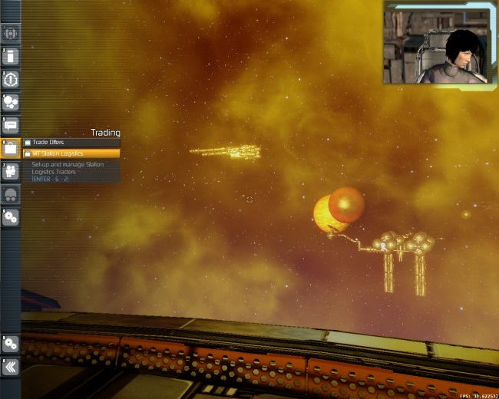 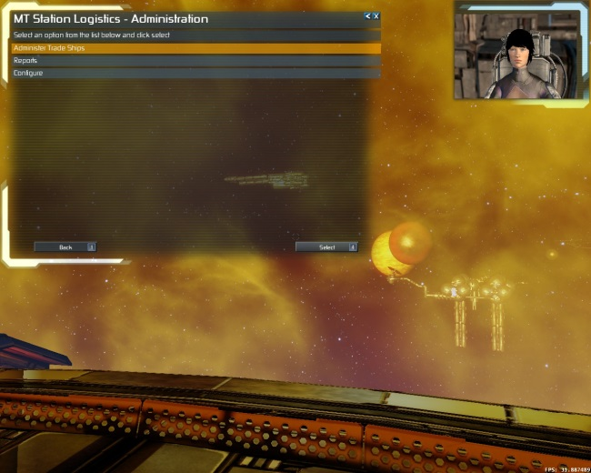

Select “Administer Trade Ships” and click on the “Select” button or press 4 – this will take you to the “Administration” screen. Assuming that you have a ship that meets the requirements in the previous section you should see it in the list of “Un-configured ships available (#)”. Highlight your chosen ship and you will see that the “Add” button becomes active.

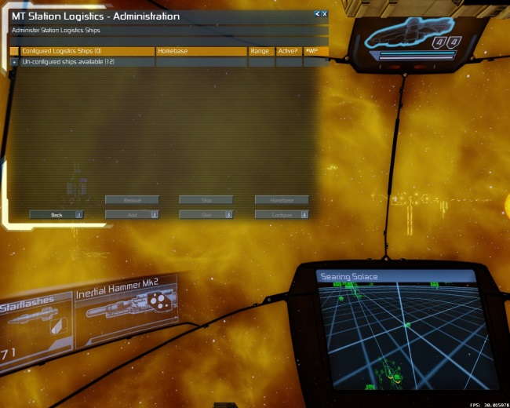 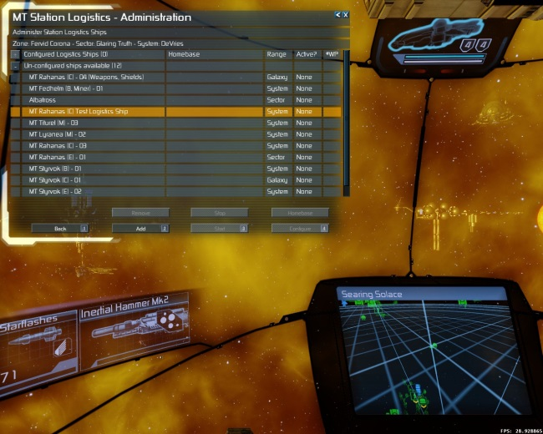

Click the add button and the ship should be added to the list of “Configured Logistics Ships (#)”

## Assigning the ship to a station

Highlight your newly added ship in the list of configured ships. You will now see that two new buttons are active. “Remove” – Allows you to completely remove a trader. Note that this deletes all information about the trader so be careful.

“Homebase” - Click on this button now and you will be taken to the standard holo-map screen. Navigate the map to find the homebase station you want, highlight it and click “Select” to return to the ship administration screen.

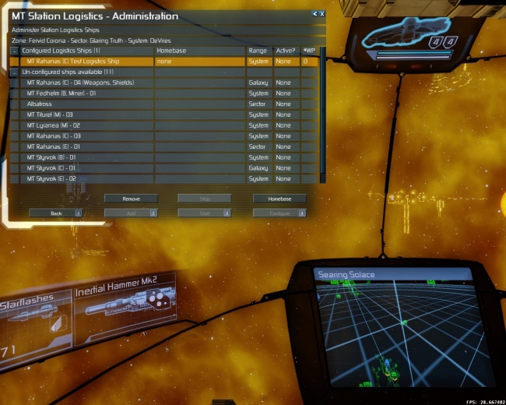 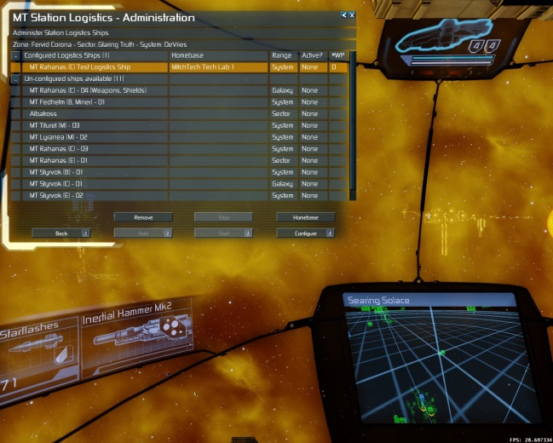

Highlight the ship again and you will now see that the ship’s homebase has been set.

## Adding Waypoints

We also now have a new button available – “Configure”. Click this and you will be taken to the waypoint list screen. At this point you will only have one button “Add Waypoint” (in addition to “Back” which cancels any changes and “Save”). Click on “Add Waypoint” and you will be taken to the Waypoint Edit screen.

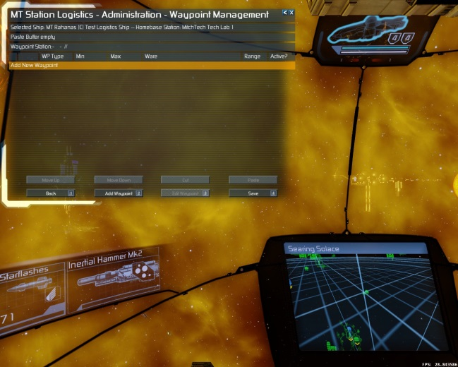 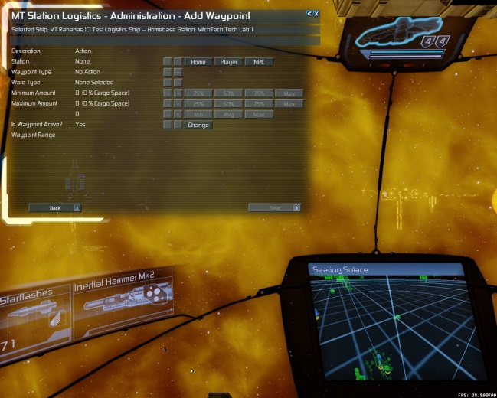

The waypoint edit screen will guide you through adding all the details needed to configure a valid waypoint (note that whilst it will help to stop you making invalid selections it will not stop you from making inappropriate waypoints e.g. If you add all buy waypoints and no sell waypoints the ship will load cargo and then sit there doing nothing as it has not been told where to sell any cargo!!)

## Add or Edit a waypoint

For this example we will add a waypoint for our homebase. Click on the “Home” button and the waypoint’s “station” line will be set to the ship’s homebase. We want to load a product to sell so click on the “+” button next to the “Waypoint Type” line until “Load” is set.

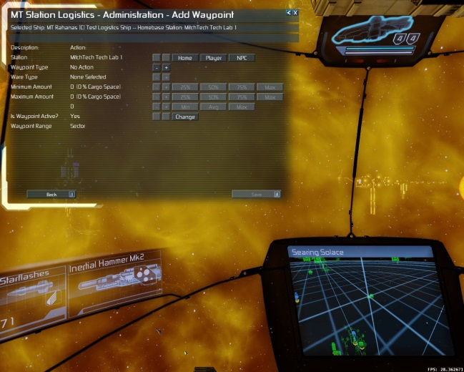 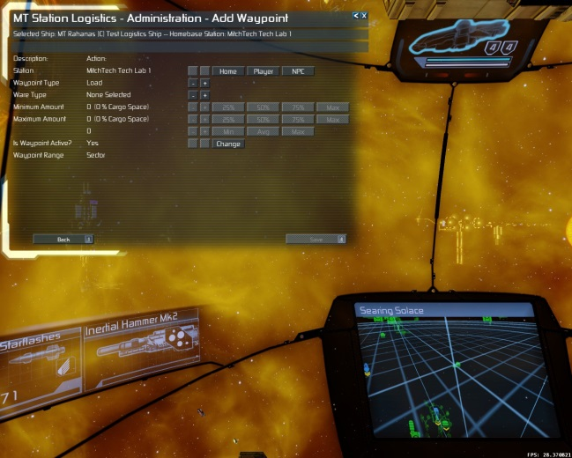

Now select the ware type, again using the “+” and “-“ buttons to scroll through the list of products at the station. In this case we’ve selected “Bio-optic Wiring” and now you can see that we have cargo amount selection available.

The “Minimum Amount” is the lowest amount of cargo that the ship will consider the waypoint is valid – so for example if our home base only had say 300 units available then the waypoint below would be skipped as it requires a minimum of 458 units to be viable.

The “Maximum Amount” is the maximum amount of ware that we will carry on this ship at any given time. So even if we set another “load bio-optic wiring “ waypoint the ship below will never ever have more than 4583 units on board at any time. This means you can segregate the cargo hold effectively so that for example a ship could trade in say 2 wares – If there was no demand for ware number 1, we would still be able to trade ware number two as we will never lock out the cargo hold by filling it up with ware number 1.

The four larger buttons to the right of the Amounts lines are percentages of the hold for that particular ware type. So if you have, for example a Styrvok with container and energy storage this amount represents the amount of space in the container storage and not the total cargo space.

The “+” and “-“ buttons on the Amount lines will increment and decrement in multiples of 1% of the hold space (rounded down to ensure we don’t exceed cargo space limits)

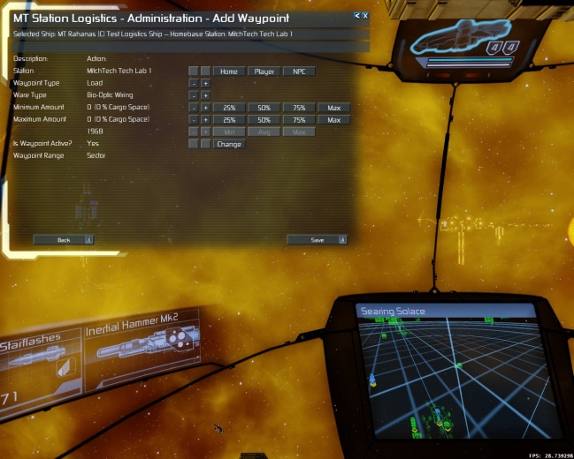 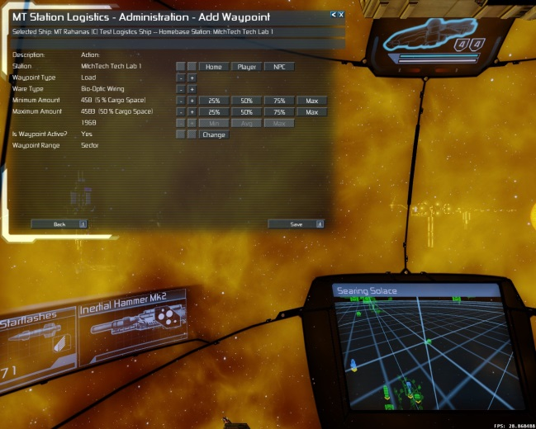

As this is a player owned station there is no requirement to set any prices. Click “Save” to save the waypoint.

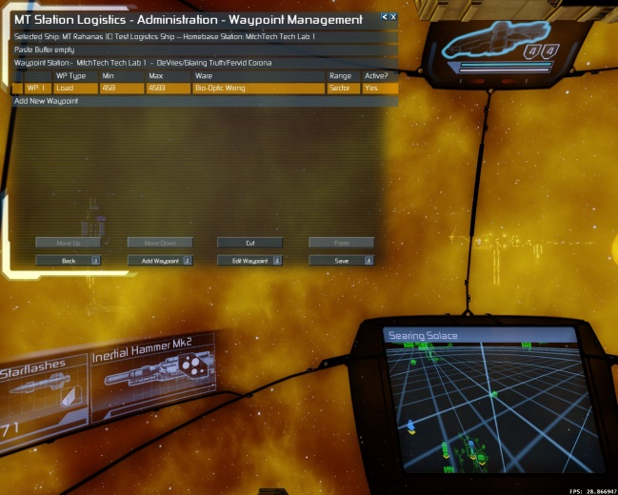

We’ll now add a second waypoint to sell the wares:

This time it’s another player station that needs the bio-optic wiring. To add this station we clicked on the “Player” button and used the standard holo-map to select our target station. Click the “Save” button on the “Add waypoint” screen to save the waypoint and go back to the waypoint list (pic 2 below)

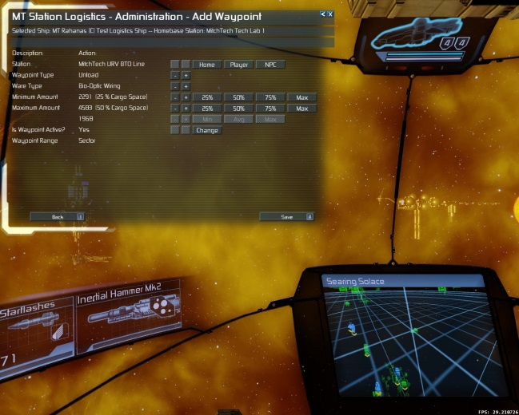 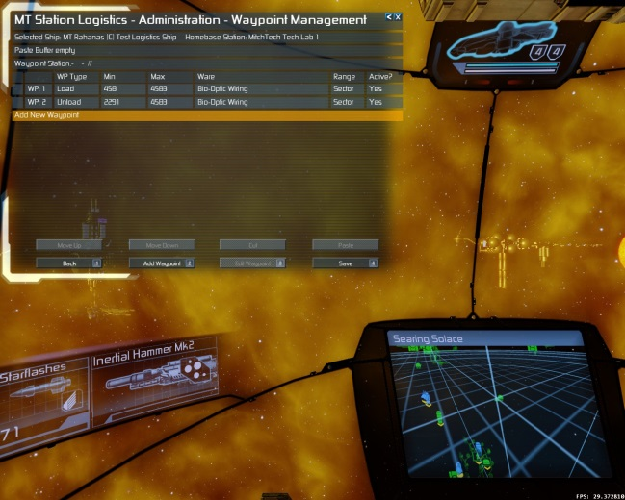

Click the “Save” button on the waypoint list screen and you’ll go back to the ship administration screen. Highlight the trader and click on the “Start” button. Congratulations! You’ve just configured your first X Rebirth Logistics Trader. Note that if you have less than two waypoints, the ship cannot be started and the “Start” button will be greyed out

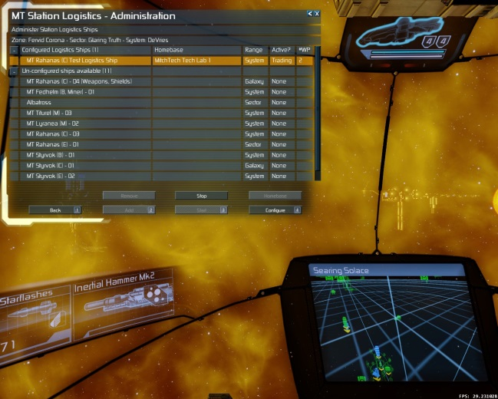

You’ll see now that we have a viable (albeit very simple) route. Our trader will fill up with bio-optic wiring at its homebase and transport the ware to our URV factory. This will continue for ever until you press the “Stop” button. If your homebase runs out or the URV doesn’t need any bio-optic wiring then the trader will go on standby, checking periodically if either of its waypoints have become viable. So, assuming your homebase Tech Fab keeps producing, your URV factory should never run out of bio-optic wiring. And they should all come from your trader.

One final thing to note is that now your trader is active it will be assigned to the homebase station and will be found under the tab for the station in the normal (menu-2-2) property listing. The ship will use the homebase station account for all transactions except for crew training fees which will come out of the player account. Be sure to check you station manager has enough funds to keep the trader busy and also to pay the wages of the trader. The trader will stop until they get paid.

# Reference Section

## Introduction

In this section you will find more details about the various functions found in the Logistics software including some examples of likely usage scenarios, some technical details of how it all works and a general reference as to what each function actually does.

## The Administration Screen

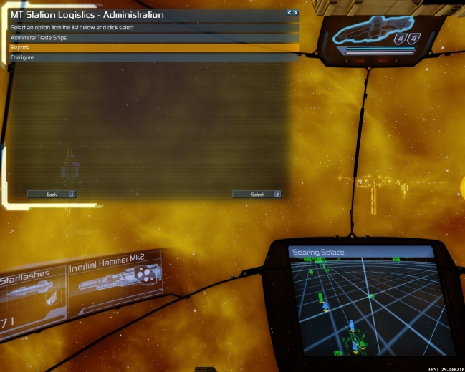This screen is the starting point for navigating around the configuration options for the software.

### Administer Trade Ships

This takes you to the main configuration screen for the administering ships and adding and editing waypoints.

### Reports

This takes you to a new screen where information about ships, crews and admin tasks can be accessed

### Configure

This takes you to a new screen where currently you can select the option to uninstall the software. Other functions may be added here in future.

## The Administer trade ships screen

This screen consists of two expandable lists.

The top list contains ships that have been configured as traders and shows some basic information about them such as:

* Name of ship – column 1
* Homebase assigned – column 2
* The range of the currently selected crew – Column 3
* The current activity of the ship (None or Trading) – column 4
* The number of waypoints currently assigned to the ship – column 5

You will also see the current location of the ship in the 3rd from top header row.

The bottom list contains all the player ships that are eligible for configuring as logistics traders. To be in this list they must:

* NOT be in the player’s squad
* NOT be assigned to another station or ship commander
* Have at least 5 cargo lifter drones fitted (not cargo)
* Have a crew that has a captain

You will note that the range of these ships is shown to help you choose what to do with them.

### Buttons

Bottom row (left to right)

Back – (Keyboard shortcut 1) Returns to the Main screen

Add – (Keyboard shortcut 2) Active if the highlighted row is an unconfigured ship. Adds the ship to the configured list

Start – (Keyboard shortcut 3) Active if the ship is in the configured list, has a homebase assigned and has at least two waypoints. Starts the ship going on its defined route.

Configure – (Keyboard shortcut 4) Active if the ship has a homebase assigned. Navigates to the Waypoint List screen.

Top row (left to right)

Remove – Removes a ship from the configured list. The ship must be stopped i.e. not trading. Note that this will delete (forever) all waypoints and log information related to the ship. The crew will retain their service records though. Use with caution!!

Stop – This will be active if an active trader is highlighted. It will stop the ship from trading. You can do this at any time but be careful:

* If you stop the ship whilst it is docked it may not undock until you give it another order or start it again.
* If you stop a ship and it happens to be in the middle of a dangerous area it will be a sitting duck so make sure you order it somewhere safe if you’re not sure.

Homebase – Active if the highlighted ship is in the configured list. This button can be used to add a homebase to a new trader or change the homebase for a trader who already has one assigned

## The Waypoint List Screen

This screen allows you to add, edit and manipulate the order of waypoints assigned to a ship. The order that the waypoints appear in this list is the order that the ship will analyse them. The 3rd and 4th header rows show paste buffer content and the target station for the waypoint respectively.

### Buttons

Bottom row (left to right)

Back – (Keyboard shortcut 1) returns to the ship administration screen

Add Waypoint – (Keyboard shortcut 2) Brings up the waypoint edit screen configured to add a new waypoint to the list. Note that the new waypoint is always inserted above the highlighted row. If you wish to add a waypoint to the bottom of the list then select the “Add new waypoint” row. If you want to add a new waypoint at the top of the list then select the first row before clicking the “Add” button.

Edit Waypoint – (Keyboard shortcut 3) Active if the highlighted row is a current waypoint. Brings up the edit waypoint screen with the details of the waypoint for changing.

Save – (Keyboard shortcut 4) Saves the current list and returns to the ship administration screen

Top row (left to right)

Move Up – Moves the waypoint up one place in the list

Move Down – Moves the waypoint one place down in the list

Cut Waypoint – Cut the selected waypoint and copy it into a buffer. Note that the paste buffer is only one waypoint deep so if you press this twice the first cut is deleted forever!! Pressing cut and then saving also has the same delete effect as the paste buffer is flushed when save is clicked.

Paste Waypoint – Pastes the content of the paste buffer to the position above the highlighted cursor e.g. if the cursor highlight is row 15 then the waypoint will be pasted at position 15 and the highlight will move down a row to 16. This function is handy for repeating waypoints (see later)

## The Waypoint Edit Screen

This somewhat complicated screen allows you to edit or add a waypoint for your trader. The title will change to indicate if you are adding or editing. The second subtitle row will show the trader and homebase. The standard buttons at the bottom “Back” and “Save” allow you to return to the previous (waypoint list) menu cancelling or saving changes respectively.

The buttons are fairly self-explanatory but are described here for completeness:

Top row:

“Home” – selects the homebase as the target station for the waypoint

“Player” – brings up the holo-map restricted to selecting stations belonging to the player.

“NPC” – brings up the holo-map allowing selection of non-player assets. Note that due to the way the standard holo-map works it is not possible to lock out selecting assets other than a station. You will get a warning if you try to select an asset that is not a station. Note that NPC stations must be friendly and also you must have a trade agent on that station in order to add it as the target station. Note also that if you select a station that does not deal in any wares that can be carried by the ship you will get a warning – you can still execute a “Fly To” instruction for this station.

Second row:

“+” and “-“– cycle through the waypoint types; No Action, Load, Unload, Buy, Sell, Fly To and Refuel. Load and unload are restricted to player stations. Buy and sell are restricted to NPC stations. Refuel is restricted to Cell Recharge Facs. The list will be filtered depending on the type of station chosen so that only valid choices can be made.

Third Row:

“+” and “-“– cycle through the wares that can be handled as a result of the station and waypoint type selected. Also filters out any wares that can’t be carried by the ship.

Fourth row:

This row sets the minimum amount of the ware that the ship will make the trip for so if it’s a buy/load waypoint the ship must be able to load AT LEAST this much ware. The “+” and “-“ buttons increment and decrement this amount in steps of 1% of the cargo hold. The 25%, 50%, 75% and MAX buttons pre-set this amount to the values marked.

Fifth row:

This sets the maximum amount of ware that will ever be present in the cargo hold. The ship will never load an amount that will cause this limit to be exceeded. If another waypoint on this list exceeds this amount then that waypoint will override and be the new MAX amount. This is done so that a trader can be set up to deal in several wares and prevent multiple load waypoints from locking out the cargo hold and preventing trade with the other wares on the list of waypoints. . The “+” and “-“ buttons increment and decrement this amount in steps of 1% of the cargo hold. The 25%, 50%, 75% and MAX buttons pre-set this amount to the values marked.

Sixth row:

This sets the buy or sell prices for the waypoint – it only applies to NPC trades as player station trades will always happen regardless of ware price. Its meaning is dependent on the waypoint type:

For a buy waypoint this sets the maximum price a trader will pay for the goods

For a sell waypoint this sets the minimum price the trader will sell the goods for

Note that for refuel waypoints it is assumed that this is needed and the trader will pay any price for fuel.

Seventh row:

This is simply a manual switch that allows the player to override the waypoint. If set to “Yes” the waypoint will be analysed as normal and followed if viable. If set to “No” the trader will skip this waypoint without analysis.

The eighth row indicates the range of the waypoint relative to the homebase.

## The Reports Screen

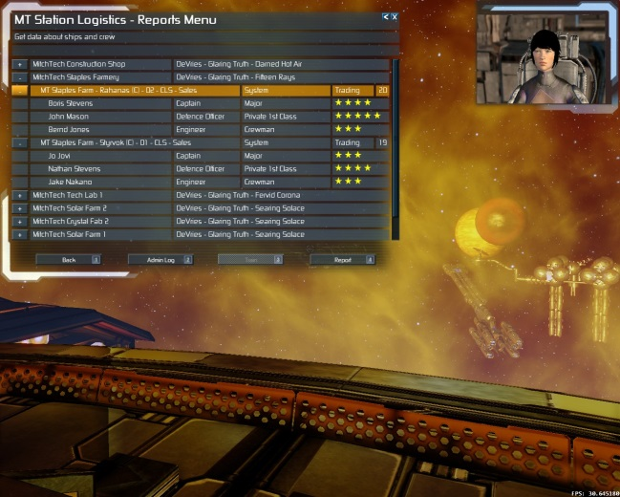This screen allows access to various data about your trader ships and their crews as well as an administration log that tells you what you have changed. The list is organised in 3 expand levels:

The top level lists all the stations that have logistics traders assigned to them plus and additional row that lists crew that is not on a logistics ship but once was and therefore has gained some experience points. You can see the name of the station and its location

The first expand level for each station lists the ships that are assigned to that station. The ship row shows the ship’s name, its range (based on its current crew), its activity status, and the number of waypoints it is currently flying.

The second expand level lists the currently serving crew on each ship. The row lists the crewmember’s name their designated function (as per the game), their current rank (as per this mod) and a summary of their skill level in the familiar star notation. If you highlight a crew member row you will see how many experience points they have available for training in the third header row.

### Buttons

Bottom row (left to right)

Back – (Keyboard shortcut 1) returns to the ship administration screen

Admin Log – (Keyboard shortcut 2) Brings up the administration log that shows key actions such as when a trader was configured, started, stopped etc.

Train – (Keyboard shortcut 3) Active if the highlighted row is a crewmember. Brings up the crew log and training screen

Save – (Keyboard shortcut 4) Active if the currently highlighted row is a ship. Brings up the ship log for that ship.

## The crew log screen

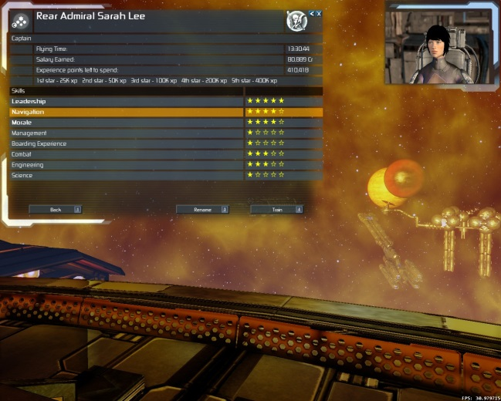Here you can see various statistics for your crew member and train your crewmember if you have enough cash and the crew member has earned enough experience points to progress.

### Buttons

Bottom row (left to right)

Back – (Keyboard shortcut 1) returns to the report screen

Rename – (Keyboard shortcut 3) Allows you to rename your crew member – be careful as the old name is not recorded so you’re stuck with the new name if you ever uninstall the mod.

Train – (Keyboard shortcut 4) Active if the highlighted skill row can be trained (only bolded ones), and you have enough cash and XP to buy the next skill star. The XP required to buy each star is shown in the last header row before the skills. Note that you will also be charged the same amount in credits for each star bought. e.g. Buying the fifth star for a crewmember will cost that crew 400,000 XP and you will be debited 400,000 credits.

## The Ship Log Screen

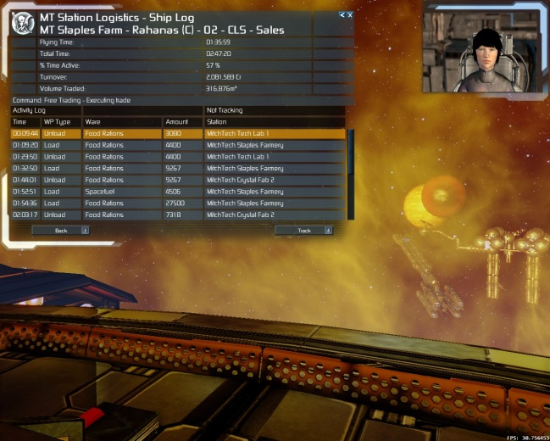This screen shows various statistics about the ship including some all-time stats such as time, volume traded and turnover. Also a list of completed trades is shown when the screen is in activity mode. When the screen is switched to tracking mode you will get real-time updates of what a ship is doing including any waypoints that the ship skips and why. The tracking log is limited to the last 30 entries.

### Buttons

Bottom row (left to right)

Back – (Keyboard shortcut 1) returns to the report screen

Track – (Keyboard shortcut 4) This button toggles the tracking mode as described above

## Technical Information

### Usage examples

This is not an exhaustive list as there are many ways that the software can be used to enhance productivity and galactic market penetration. You might want to refer to the old X3 guides for CLS Mk2 traders as the principle used here is very similar to that software.

### Simple guaranteed ecell supply to all player stations in a sector.

* 1. Pick a fast energy freighter such as a Styrvok for this job
  2. Set the homebase for the trader to be one of your solar array stations.
  3. The trader’s first waypoint should be to load – ecells – max cargo; set the minimum quite high so that the trader only tops up when necessary.
  4. Now set a waypoint to unload for each station in the sector that uses ecells. Set the minimum delivery fairly low say 10% and the maximum to be the full amount
  5. Set the trader going and you should pretty much ensure that all your stations in that sector never run out of ecells

Some subtle variations: if you’ve used a sector range trader for this you will no doubt have used up all ten waypoints by now. One slight problem with this setup is that the trader will keep visiting the first drop on the list until it is full, then the second and so on. This means those stations at the end of the list will starve until the trader has filled the ones at the start. To overcome this, switch your crew to a system level crew with 20 waypoints instead of ten. Now use the paste function in the WP list to place a load waypoint in between every unload waypoint. This will ensure that the stations are visited one by one in turn on every sweep of the waypoint list. Use the move up and move down buttons to place the most desperate stations close to the top of the list.

### Galactic Sales Executive.

So you dutifully built a URV forge for the plot in DeVries but no-one in DeVries really wants the drones right? No problem – set up a galaxy trader to load 50% cargo hold of MK1 Interceptor. Add each of the major shipyards as a sell waypoint for the URVs (note that you will need to have already chatted up some granny to send you trade updates from the ship yards). This should keep ticking over quite nicely earning your plot station a nice little profit. With the other 50% spare cargo space you could use the freighter to gather needed resources such as food and spacefuel so the ship is not sat idle for long ( you could have course used the entire hold to flog URVs but the ship would likely be idle for long periods) Remember with high value goods it’s actually worth selling small quantities as cheap as you can as you’ll always then undercut the NPCs. If your station is part of a loop that is making URVs for (next to) nothing then you can make a fortune this way by selling always at minimum price.

### About Wages

Crew will earn a salary based on flying time. They won’t earn anything whilst analysing waypoints so if they are sat idle they are not earning anything.

Level 1 (Sector range) crews earn 20Cr per minute of active flying time

Level 2 (System range) crews earn 50Cr per minute of active flying time

Level 3 (Galaxy range) crews earn 100Cr per minute of active flying time plus if they sell goods to an NPC station they earn 0.5% commission on the sale value exceeding minimum ware value e.g. if the sell 100 food rations at 30 credits each they will earn 0.5% of (30-24) x 100Cr – not a bad little earner so be careful about sending level 3 crews jumping all over the galaxy supplying ecells – they will bankrupt you!!!

The captain earns 100% of this amount, The DO earns 75% of this amount and the engineer earns 50% of this amount.

Note that wages are paid every 30 minutes from the station’s account. You will notice that the money first enters the player account and then leaves it as this was technically the only way to achieve a reduction in the station’s balance.

### About XP

XP is pretty much linked to salary earned in that each crew member gets 1 XP point for every credit in the base salary calculation – no apportionment based on function as there is with salary – they all get the same.

### About waypoint list sweeps

The time taken to analyse the list is dependent on the captain’s navigation skill the higher the skill, the lower the time it takes to analyse each waypoint and act.

If the waypoint list is analysed from start to finish and has no viable trips this is classified as a null sweep. If a trader gets a null sweep they will undock from their current location and idle in space for the next sweep. If 5 null sweeps are encountered then as a safety feature the trader will fly back to the homebase.

### About Refuelling

You can add refuel waypoints to help direct your ships to fill up at your own cell recharge facs. We do however recommend you leave the auto refuel setting on to prevent the captain getting stranded and bugging you for instructions (the mod uses Ego’s standard move.generic script for navigation)

### About station managers

Station managers are aware of Logistics ships due to a little patch of their script. They will not use logistics ships to assign to normal station duty. You can assign ships to the manager and they will function just the same as normal. In other words you can have the modded logistics ships happily working with the vanilla ships.

### And Finally……

Thank you for using MitchTech Corporation Products! We hope you enjoy the benefits and we’d be delighted to hear about your thoughts on the product (positive and negative). We will do our best to enhance the product with new features and fix things that break.

CEO Mitchell

MitchTech Corporation

**Happy space trucking pilot!**

